Annexure L – Scope of Work

- Project Alignment

Project Expressway shall be an Access-Controlled facility, and its start point is, on the right bank of Malir River, between Jam sadiq bridge and Korangi Crossing causeway and travelling along the Malir River up to the existing Link Road between N-5 and M-9 (2.4 km short of M-9) and it will take left turn from this point and terminate 100 meter before M-9 toll plaza on this link road which is the end point of the Project, as shown in the Location Plan. The tentative measured length of the expressway is 38.75 km. The exiting section of Link Road between N-5 and M-9, will need modification to meet the requirements of the Expressway according to given cross-sections.

Expressway alignment is being provided to work out the further Engineering, very minor adjustment in the given alignment is expected. All the cost estimation for bidding purpose shall be based on this given expressway alignment, any variation in alignment length up to 1% cannot be claimed by concessionaire or GOS. The alignment data is being provided in table # 1.

- Required Configuration Of Interchanges/intersection

The Project Expressway being an access-controlled facility, therefore following entry and exit points at Interchanges are envisaged at this stage, which shall be followed by all Bidders:

- Jam Sadiq Interchange to provide only following conflict free movements:

(At this location Malir Expressway will be grade separated with the existing bridge crossing Malir River connecting Sunset Boulevard / Korangi Road with Korangi Industrial Area)

Entry to Malir Expressway

  - Left turn for North bound traffic coming from Shaheed-e-Millat Expressway and moving towards M-9

  - Left turn traffic for North Bound expressway which is coming from Sunset Boulevard / Korangi road from KPT Flyover Bridge should have grade separated conflict free entry from traffic going towards Jam Sadiq Bridge.

Exit from Malir Expressway

  - Right turn for south bound traffic coming from M-9 and moving towards KPT Interchange

  - Left turn for south bound traffic coming from M-9 and traveling towards Korangi Industrial Area

- EBM Causeway:

  - At this location EBM Causeway will remain at grade and Expressway will continue through a flyover along this road

- Korangi-Shah Faisal Interchange to provide only following conflict free movements:

(At this location Malir Expressway will be grade separated with an existing bridge across the Malir River connecting Shah Faisal Colony to Korangi)

Entry to Malir Expressway

  - Left turn for north bound traffic coming from Shah Faisal Colony to move towards M-9

  - Right turn for north bound traffic coming from Korangi Industrial Area to move towards M-9

  - Right turn for south bound traffic coming from Shah Faisal Colony and going towards KPT Interchange/Jam Sadiq Bridge

Exit from Malir Expressway

  - Left turn for south bound traffic coming from M-9 and moving towards Korangi Industrial Area

  - Right turn for south bound traffic coming from M-9 and moving towards Shah Faisal Colony

  - Left turn for north bound traffic coming from KPT Interchange/Jam Sadiq Bridge and going towards Shaha Faisal Colony.

- Quaidabad (N-5) Interchange

(At this location Malir Expressway will be grade separated with the existing bridge of National Highway N-5 on Malir River)
Entry to Malir Expressway

  - Left turn for north bound traffic coming from Airport to move towards M-9

  - Left turn for south bound traffic coming from Thatta to move towards KPT Interchange.

  - Right turn for traffic coming from Airport to move towards KPT Interchange via Malir Expressway

  - Right turn for north bound traffic coming from Thatta to move towards M-9 via Malir Expressway

Exit from Malir Expressway

  - Left turn for traffic coming from KPT Interchange (North Bound traffic) to move towards Airport

  - Right turn north bound traffic coming from KPT Interchange and moving to Thatta

  - Left turn for south bound traffic coming from M-9 and moving to Thatta

  - Right turn for south bound traffic coming from M-9 and moving to Airport

- Interchange near km 24+050 (Exact Location to be decided)

- Expressway will be At-Grade with two (2) left turning movements and grade separated trumpet interchange for two (2) right turning movements

- Interchange near km 28+750 (Exact Location to be decided)

- Expressway will be At-Grade with two (2) left turning movements and grade separated trumpet interchange for two (2) right turning movements

- Intersection at Km 37+100 for Education City

- At Km 37+100 Expressway will hit the existing link road between N5 & M9, the alignment of this link road is being realigned due to coming Education City at this location. The Designer is required to design and construct. At-grade intersection in coordination with plans of Education City Entry approach with the design provision of grade separated interchange in future

Note: All the entry and exit lanes shall be designed for smooth transition as per standard design requirements assuring no disturbance to existing traffic movements on connecting roads/bridges.

- Structures

Different type of structures are required in the Expressway to provide the functionality of the access control facility. The detailed Engineering Design and locations of different types of structures e.g. Flyover, Railways Bridge, Nala Bridges, Culverts, Underpass, Cattle Creeps etc. required detailed reconnaissance survey of the project alignment to ascertain their numbers. The bidder has to then prepare his bid on the basis of his own assessment.

The minimum internal size of culverts shall be 1.50m x 1.50m and the pipe culverts shall not be less than 1220mm internal diameter. The size of typical underpass and cattle creep are being provided in figure No.5.

Railway Bridge
Malir Expressway also crosses the main railway line at Km 14+900 where an appropriate grade-separated arrangement shall be provided in close coordination with Pak Rail for safer and smooth flow of traffic across the line.

- Typical Cross-Sections

Typical cross-sections of expressway, bridges, slip roads and entry exit ramps are provided in given Figure No 1 to 5

- Project Components

Project Components include detailed design, construction, operation and maintenance of following listed items:

Not limited to as specified below, overall components of design, and construction of the Project are as follows:

- Project Expressway shall be an access-controlled facility.

- Prior to finalizing the alignment, carry out map / satellite imagery study supplemented with area reconnaissance and study for the Expressway, the Concessionaire will present to the Independent Engineer (IE) and the GoS, final alignment with merits and demerits after ground assessment and salient features. This alignment should be based on findings and recommendations of Hydraulic Study, High Flood Level and its extents on both sides of Malir River.

- Detailed designing of the Expressway should be based on the given design criteria and provided typical X-Sections. The Concessionaire shall be responsible for all aspects of Design in conformity with applicable standards, safety and in accordance with the Concession Agreement, including the Design requirements as set out in relevant article and schedule of the Concession Agreement.

- Carryout the Hydrological studies of Malir River and based on this study placement of alignment, height of embankment, protection and erosion control of the embankment slopes shall be decided for the final design.

- Should take into consideration river flow patterns during peak flood for 50 years return period. A Report prepared by Water and Power Development Authority entitled “Feasibility Report Karachi Flood Control Plan” prepared in the year 1983 and updated in the year 1990 will be made available to the Bidder for reference only. It may be noted that expressway embankment height including interchanges shall nowhere be lesser than the existing protection bund top level already constructed from start point up to Quaid Abad bridge.

- Carry out design and construction of Flexible Pavement.

- Design and construction of Embankment height and slopes, retaining / protection works, erosion protection works and drainage works in view of findings and recommendations of Hydraulic Reports mentioned above.

- Design and construction of road safety elements like road side safety barriers, road furniture which includes:

  - Pavement markings, lines, arrows and studs;
  - Guardrails at high embankment locations;
  - Traffic direction signs;
  - Information signs;
  - Warning signs;
  - Gantries;
  - Vision and Sound Barriers,

- Carry out design and construction of bridge structures for flyovers and interchanges.

- Carryout detailed design and construction of interchanges, Intersections, underpasses, and cross-drainage structures.

- Carry out detailed design and construction of electrification of interchange & toll plaza, toll building and control building.

- Carry-out EIA Report and to seek approval from EPA as per their rules and regulations and as per applicable International Financial Institutions (IFIs) environmental standards. (Land acquisition and clearance of encroachment will be the responsibility of the GoS).

- Carry-out Detailed Design and construction of toll gates / toll plaza, and its control building. The size of Plot of Control Building for each toll plaza should not be less than one hundred square metre (100 sq.m.) out of which seventy percent (70%) should be covered area.

- Carry-out Detailed Design and construction of Main Control and Administration Building having one thousand square meter (1,000 sq.m) area out of which seventy percent (70%) will be covered area. Location of this building shall be selected in consultation with the Independent Engineer (IE) and GoS.

- Carry-out detailed design and construction of weigh bridges and its office.

- Prepare construction drawings and reports based on approved detailed design of all components of the Project Expressway.

- Give detailed plan of implementation strategy.

- Prepare land acquisition plans based on Final Design.

- Prepare properties demolition plans (demolition of encroachments / properties shall be executed by the EPC contractor).

- Prepare plans showing relocation of existing utilities within right-of-way (ROW). These plans will be submitted to the GoS for their coordination and relocation.

- Supply and installation of fence on the city side where necessary.

- Detailed Design of Project

- Carryout map / satellite photographs study and review of all material / documents / studies / alignment plans / typical cross-sections / drawings provided, supplemented with area reconnaissance and detailed topographic survey, study options for alignment in view of hydraulic studies, and present all options with merits and demerits after ground assessment of salient features of each alignment.

- Carry out soil and material investigation to determine the “Subsoil Condition”, other required soil tests and analysis for the authenticity of any available report as the Independent Engineer / GoS will not be liable to any discrepancy.

- Carry out hydrological studies for each structure by determining catchment areas for each structure.

- Carry out geotechnical investigations for bridges and other structures.

- Detailed designing of the Project based on conceptual location plans and typical cross-sections. However, the Concessionaire will be responsible for all aspects of design in conformity with Applicable Standards and in accordance with the Concession Agreement, including the design requirements as set out in the Concession Agreement. Moreover, if any existing road or network would have been affected/cut due to the design of Expressway then it will be concessionaire’s responsibility to provide permanent solution in order to restore the accessibility without any additional cost to the project.

- Detailed geometric design of road component, at grade, interchanges, intersections, flyovers, slip roads, ramps, weigh bridges, toll plaza including their approaches, underpasses, cattle creeps, culverts, slope protection works as per the design criteria given in the AASHTO standards. Also carry out flexible asphalt pavement design, design of retaining / protection works, design of erosion protection works, river training works and drainage works.

- Carry out detailed Structure Design of all the interchanges, flyovers, underpasses, culverts, weigh bridges, toll plazas and their allied buildings.

- Carryout detailed structure design of other bridges / structures and culverts in accordance with provisions of “AASHTO LRFD Bridge Design Specifications”.

- Design of other minor structures and intersections (at-grade).

- Prepare construction drawings of all road works, structure works and drainage and protection works.

- Preparation of land acquisition and utility / infrastructures relocation folders.

- Carry out Environment Impact Assessment - EIA study and submit report to seek approval from the Sindh Environmental Protection Agency as per their rules and regulations and as per applicable International Financial Institutions (IFIs) environmental standards.

- Carryout detailed Design of Toll plaza, toll control building, weigh bridges, offices and residence for operation and maintenance staff.

- Prepare Construction Drawings of all above components.

- Give detailed plan of implementation strategy.

- Design Requirements and Standards

A summary of the design criteria is provided hereunder:

Design life

Design Life (Years)
Bridges | 80
Culverts | 80
Flexible Pavement | 10
First Overlay | 10
Second Overlay | 10
Hydrology Study (return flood period) | 50
Expressway Geometric Design Standards and Criteria

A Policy on Geometric Design of Highways and Streets, 2011 edition by AASHTO shall be followed.

Criteria | Expressway | Interchange
Design speed | 100 km/h | 40 km/h
Maximum super elevation | 4.00% | 4.00%
Gradient (Max) | 3.00% | 4.00%
Gradient (Min) | 0.20% | 0.20%

Transverse Slope  Carriageway  Shoulder | 2% outer cross slope  4% outer cross slope | 2% outer cross slope  4% outer cross slope
Expressway Carriageway Width | 10.95m  (7.30m, Reduce One Lane from each carriageway from Jam Sadiq Interchange to Korangi Road Interchange & Creek Avenue Connection) | 7m  (Ramp/Loop/Slip Roads)
Outer Shoulder Width | 3.0m | 0.5m  (Ramp/Loop/Slip Roads)
Inner Shoulder Width | 1.20m | 0.5m  (Ramps/Loop/Slip Roads)
Bridge  Carriageway Width  Outer Shoulder  Inner Shoulder | - | 10.95m  1.20m  1.20m
Shoulder Surfacing | Asphaltic Wearing Course | Asphaltic Wearing Course
Embankment height | Min. 0.30 meter above the High flood level | Min. 0.30 meter above the  High flood level
Embankment side slope | 2H:1V | 2H:1V
Minimum size of Culverts  Box Culverts  Pipe Culverts | 1.50m x 1.50m (internal)  1220 mm Dia (internal)

Structure Design Standards and Criteria

Structure Design Standards:

- AASHTO LRFD

Loading Criteria:

- West Pakistan Code of Practice for Highway Bridges, 1967

Seismic Design:

- AASHTO analysis and design with latest Seismic zoning map for Pakistan as per revised current GoS seismic parameters.

Standards for Material Testing:

- ASTM -American Society for Testing and Materials
- AASHTO-American Association of State Highway and Transportation

- Embankment Design

The embankment design, its height, slopes and protection works, including apron on river side, shall be designed keeping in view of the outcome of Hydrology Study Report which shall be carried out for not less than fifty (50) years Flood Return Period. Also requirement of J spurs in the river bed, particularly where nala opening exist, should be considered carefully where deemed necessary for the protection of the embankment.

Due consideration shall be given to Road Side Barriers at high embankment locations as per design standards.

In areas of high water table, filter cut-off layer, if required, shall be provided to protect the pavement structure. This should include day-lighting of the pavement layers to outer side of the embankment. Surface drainage should also be designed properly to ensure no water ponding on expressway and interchanges during or after the rain.

- Pavement Design

The pavement designs shall be carried out as per AASHTO Guide (latest edition) with load factors from NTRC Report and confirm the design with the mechanistic design methodology. The pavement design shall be based on one hundred million (100,000,000) ESALS per Lane traffic volume and its projection. Traffic growth factors shall be established through the study of available traffic data.

Since the Project Expressway will be a new facility, and no traffic is currently plying on its alignment, volume of traffic and in turn the required pavement structure is the prime concern. As such, for bid comparison, all the Bidders should quantify and price the Flexible Pavement based on a pavement design of one hundred million (100,000,000) ESALS Load per Lane for a design life of ten (10) years. During the detail Design stage if traffic study results are showing higher traffic volume then the concessionaire will design the pavement on these higher traffic numbers and may claim the price difference from GOS. Two Overlays are envisaged for this concession, first on the eleventh (11th) anniversary of COD and Second Overlay ten (10) years after the First Overlay. Design lives of both the overlays shall be 10 years.

Other design criteria not specified herein shall be approved by the Independent Engineer (IE) before being adopted for the design.

- Protection Works:

Protection work and guide bank will be designed for high flood discharge for a return period of not less than fifty (50) years and flow pattern determined by design calculations and hydraulic study. Detail Drawings of the same will form part of Design report and construction package. As mentioned above, on both banks of Malir River, Sewerage and Storm Water outlets are discharging in Malir River. Concessionaire should keep in view this drainage/ discharge pattern during the design, due diligence shall be given to the required protection works on right bank near each cross-drainage structure and underpasses.

- Environmental Impact Assessment (EIA) Study

EIA should include but not limited to the following:

a. Review of legislation and legal framework;

b. Project features and analysis of various alternatives;

c. Identification of project’s various impacts e.g., ecological, socio-economic etc.;

d. Impacts from the surrounding ongoing and proposed development, during planning, construction and on completion;

e. Impact identification, analysis and mitigation measures;

f. Preparation of detailed Environmental management and mitigation plan during construction phase and on completion;

g. Any other requirements of the statutory authorities as required for the approval of the study and such study shall be acceptable to all international financial institutions;

h. Assisting Concessionaire in obtaining all NOCs from EPA.

j. Quantification and costing of environmental management mitigation measures.

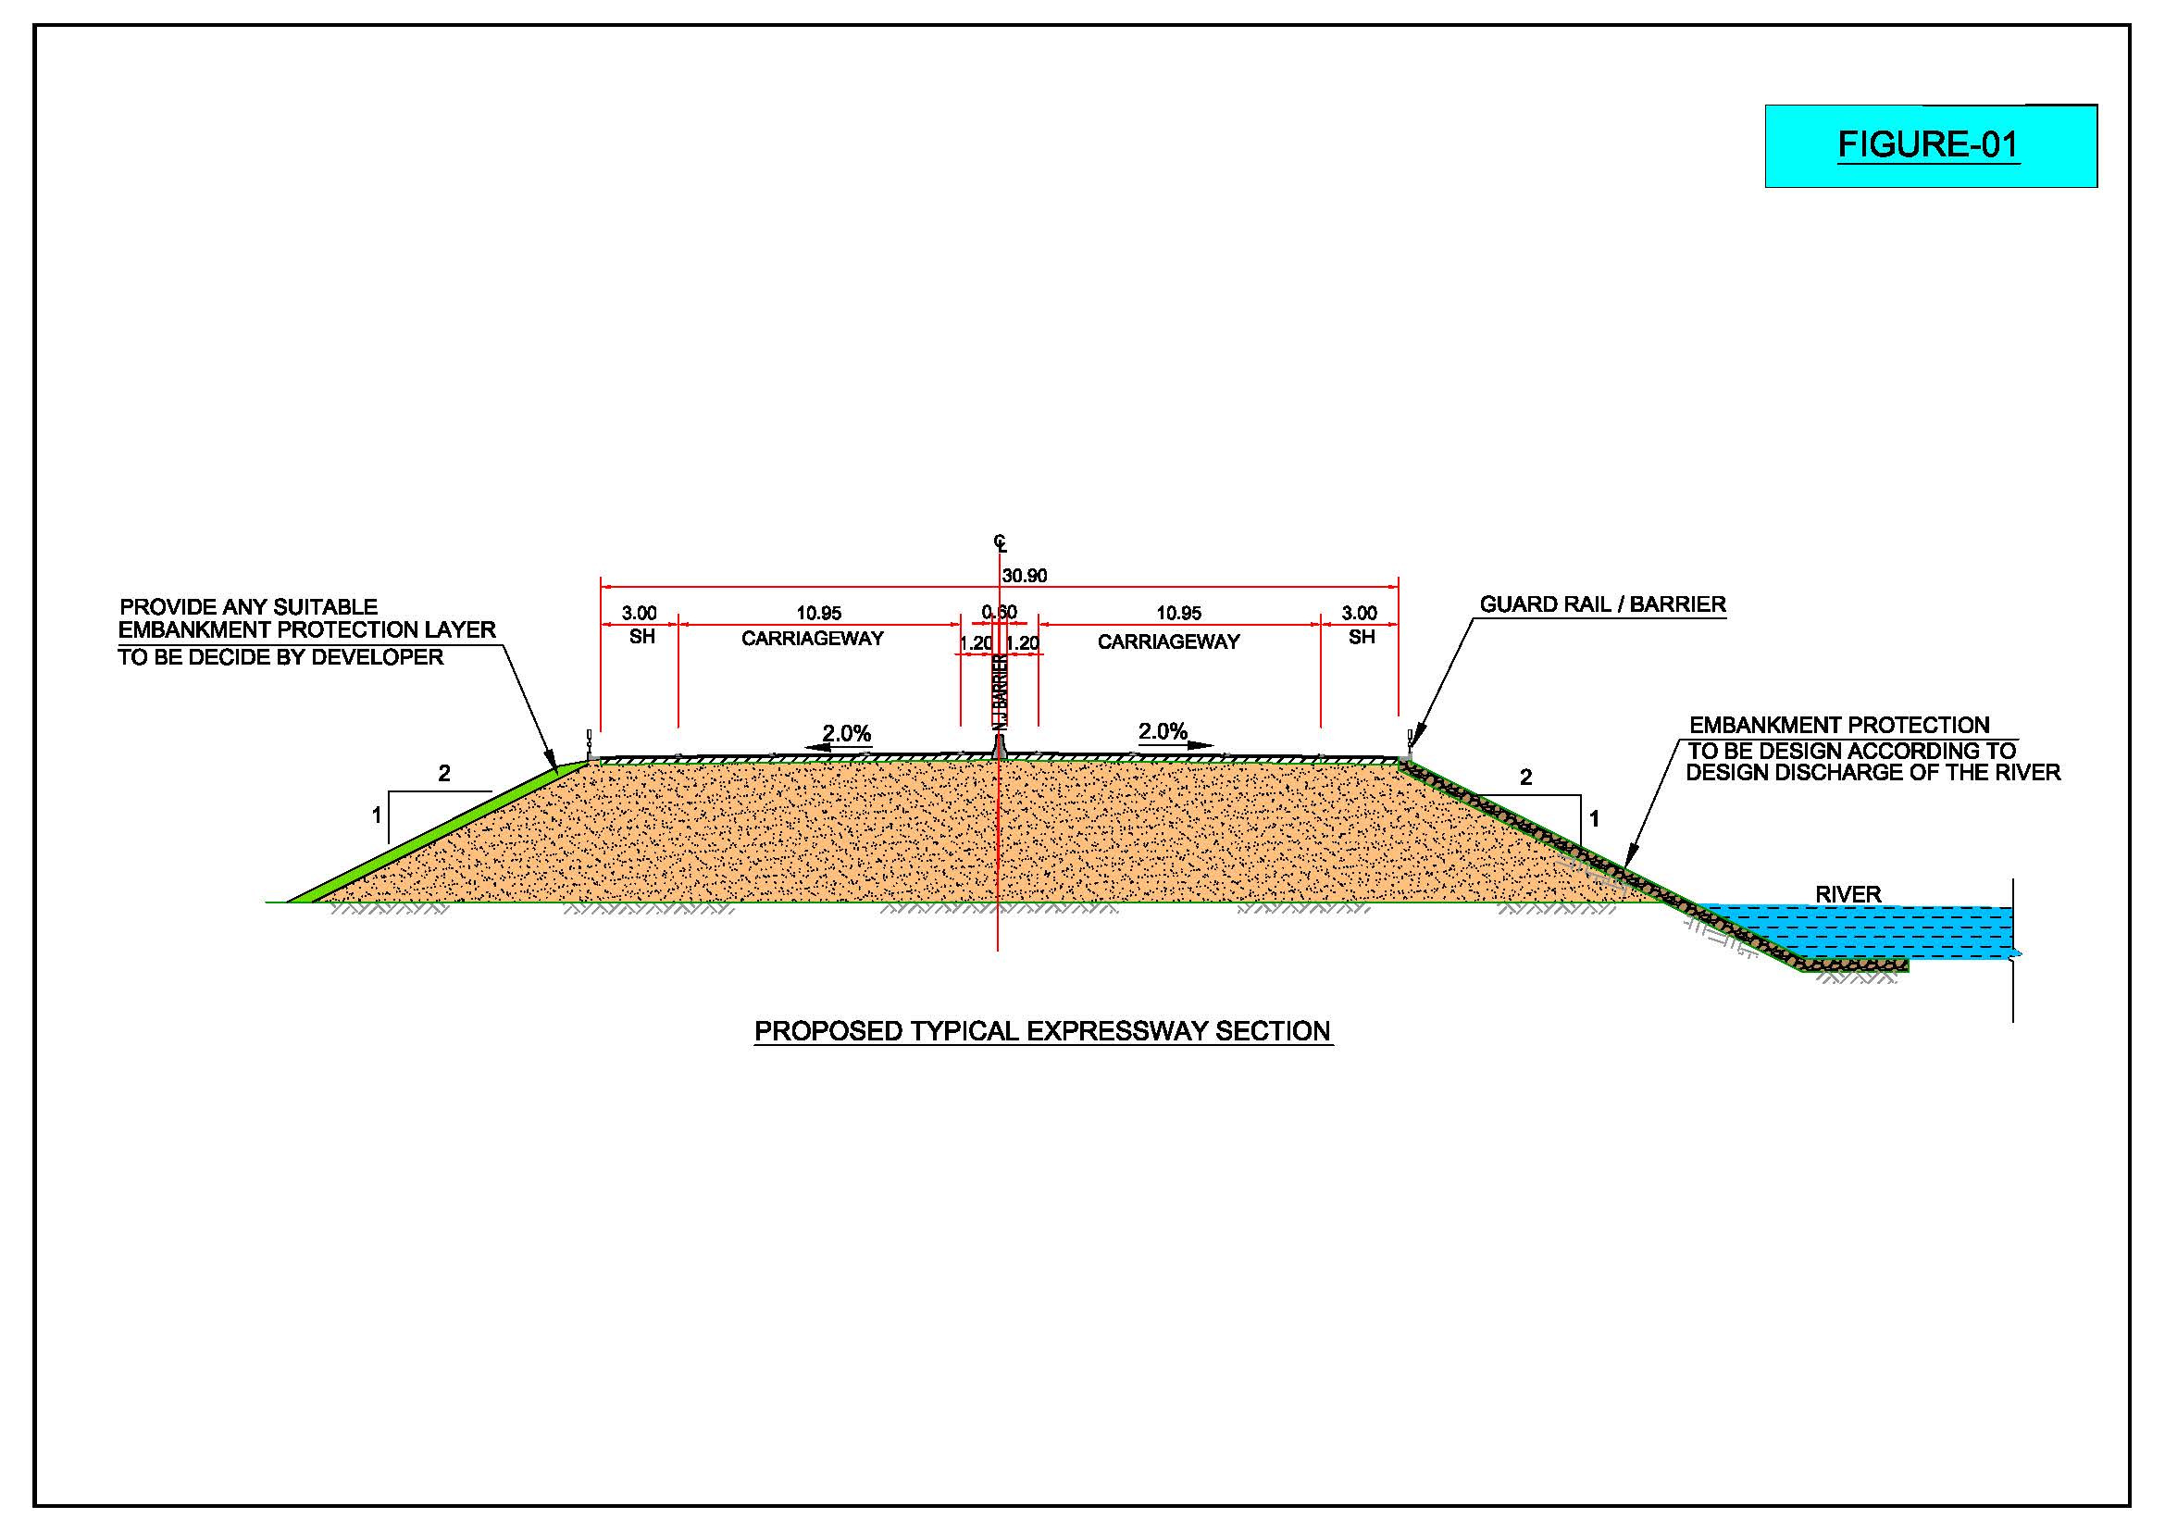

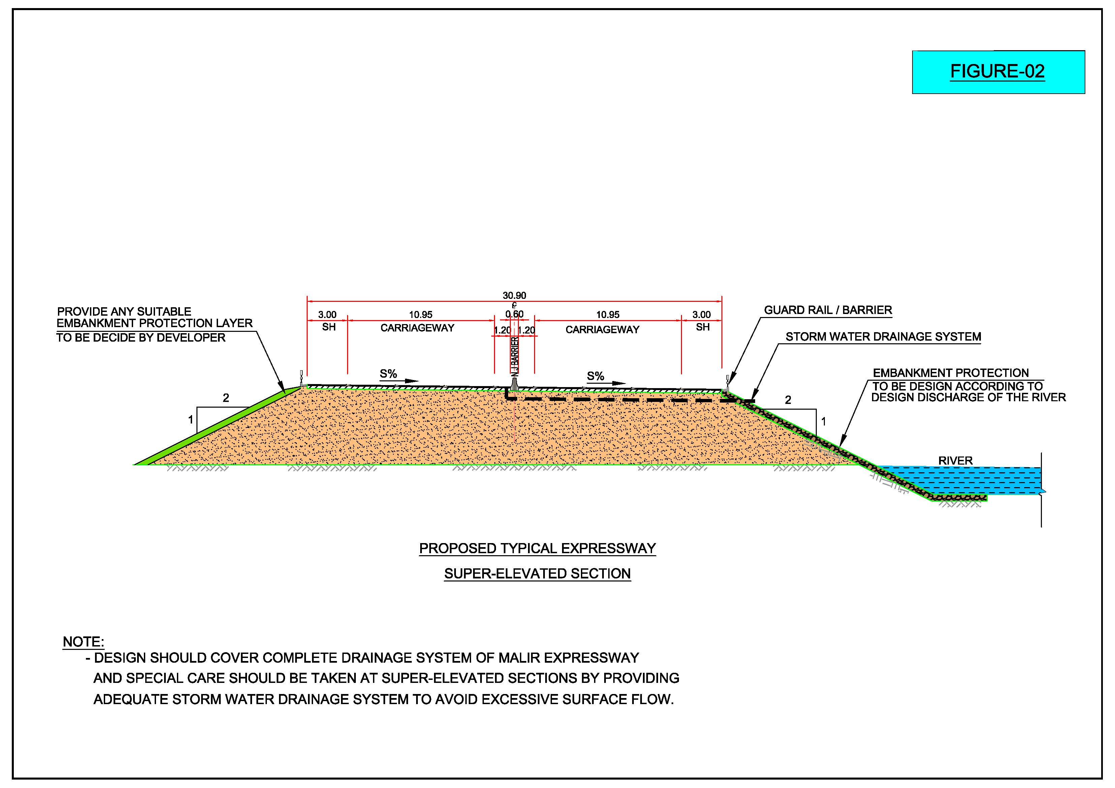

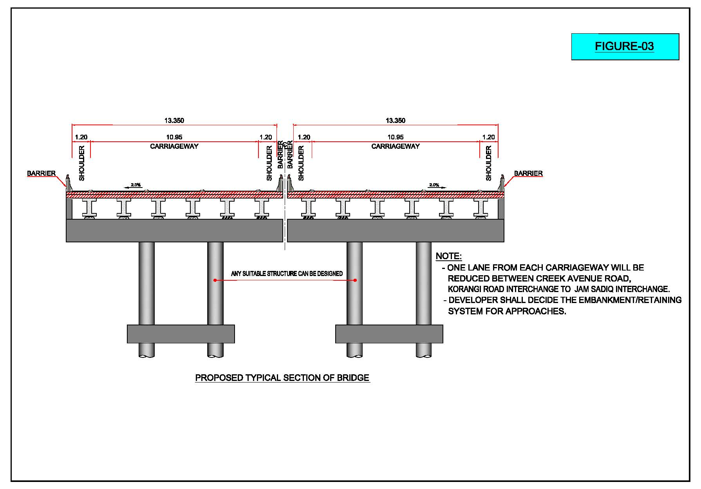

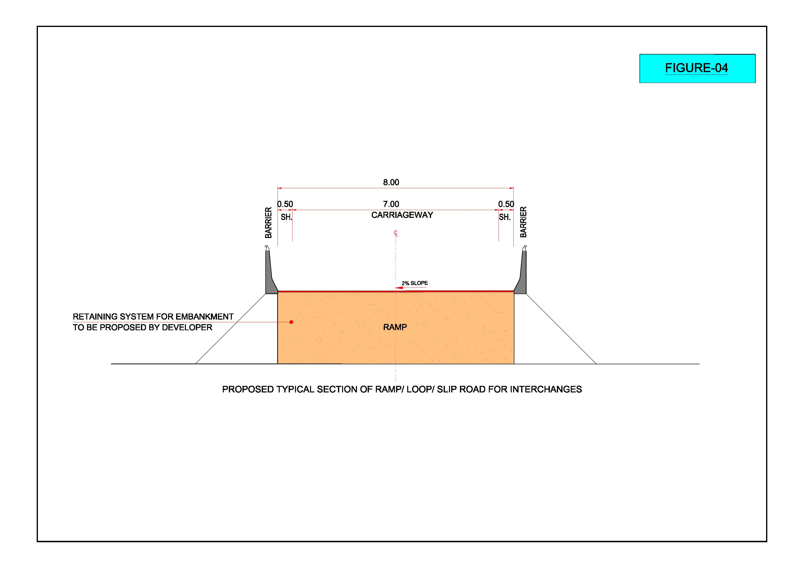

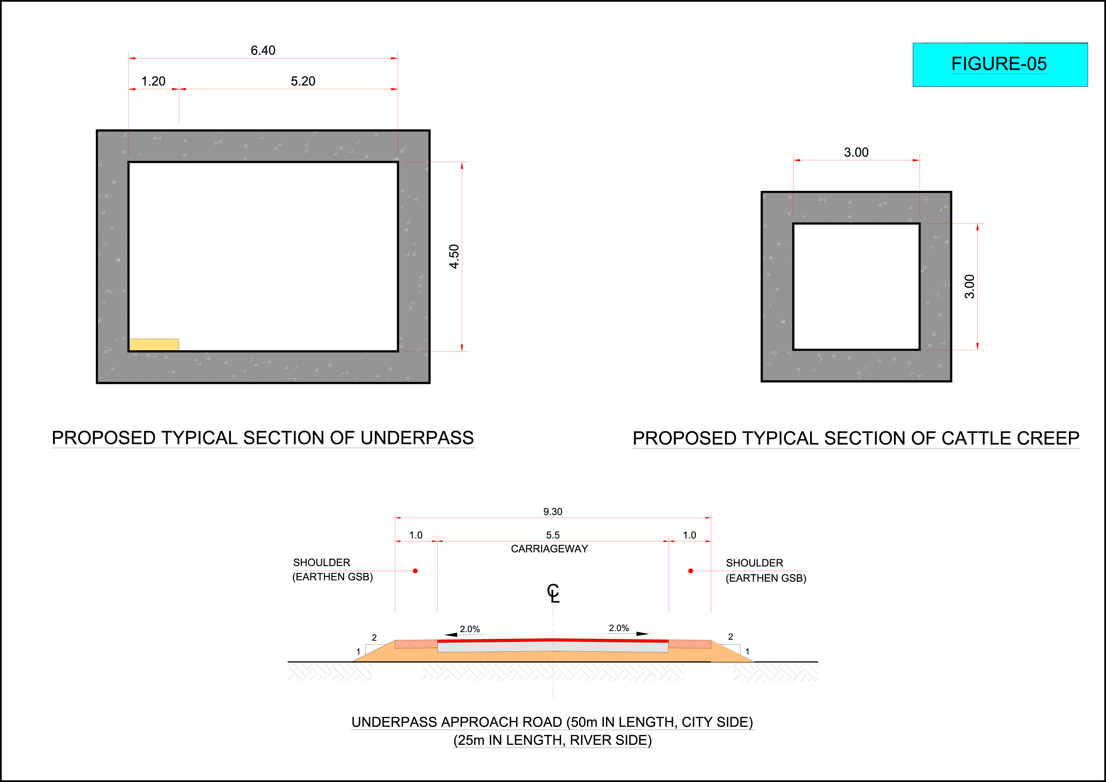

TABLE - 1

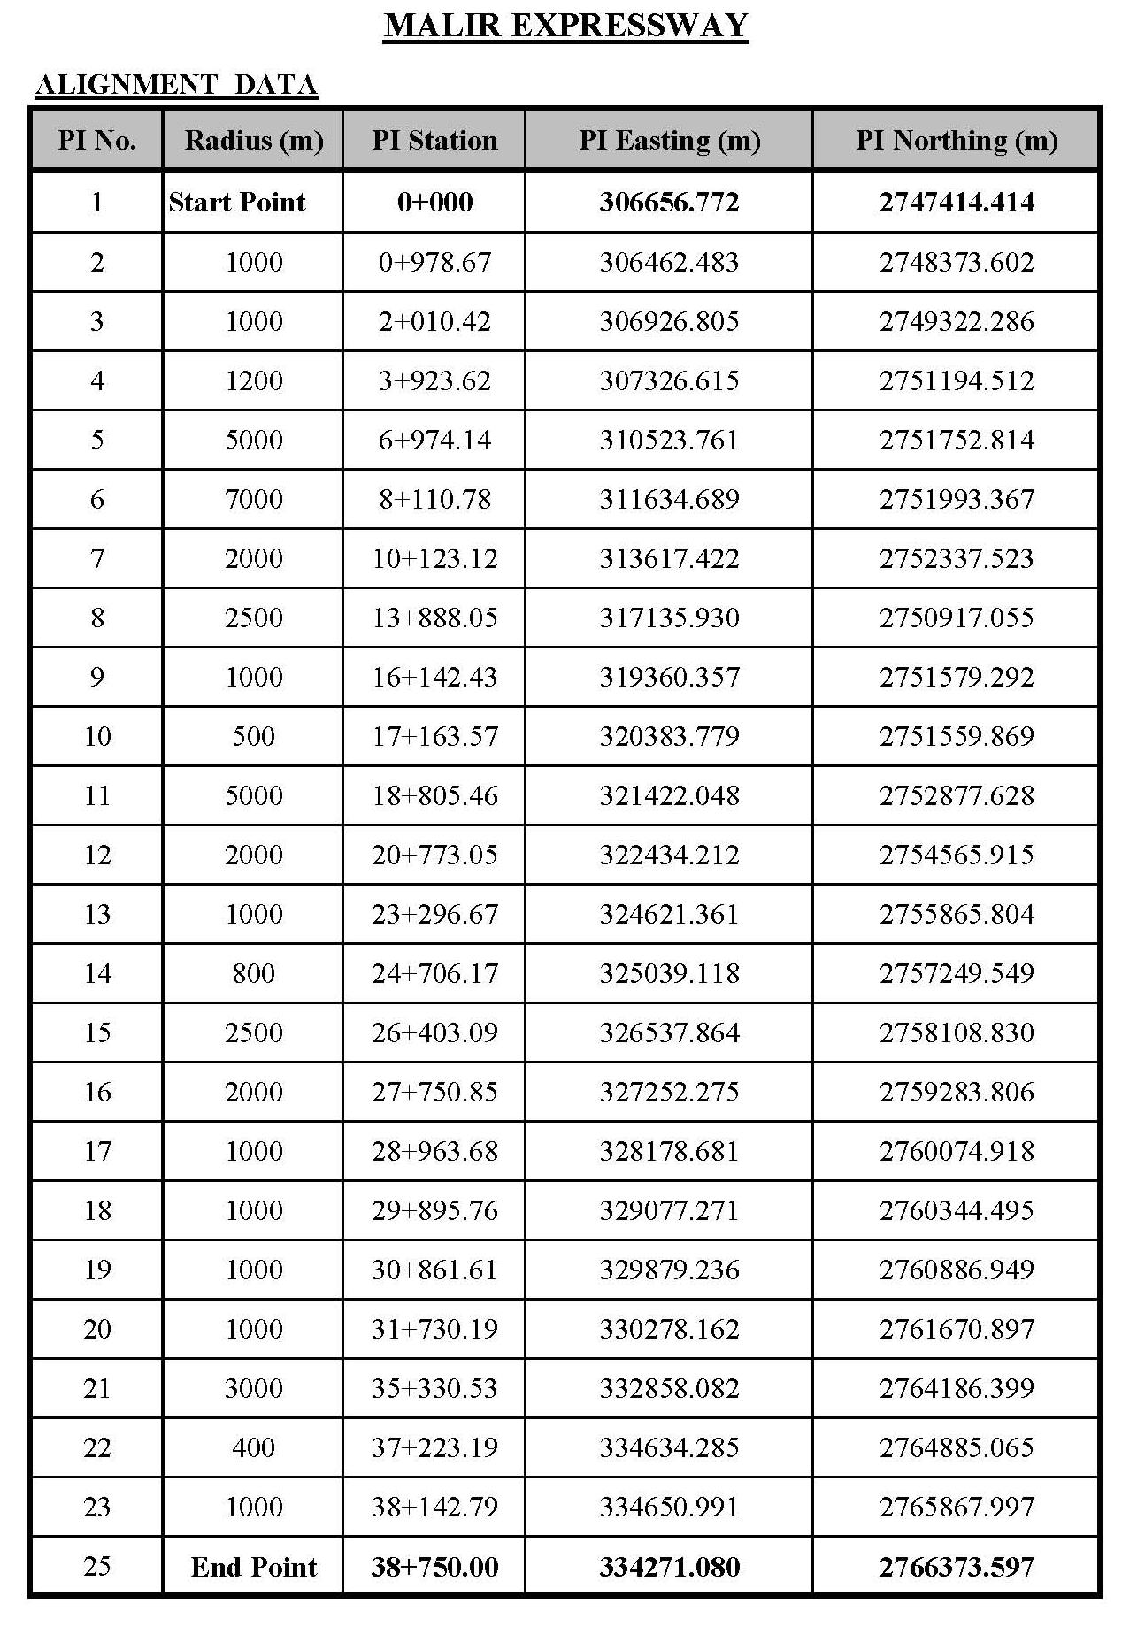

- Electrical Works

The Interchanges, Toll Plazas, Toll Buildings, weigh Bridges and Control Buildings of the Project Expressway will be provided with Lighting. Concessionaire will provide its design as per following specifications with the list of approved vendors to obtain approval from Independent Engineer (IE) before any installation.

Specifications/Standards:

• The lighting system shall be designed to BS EN 13201–2:2015. CIBSE and IESNA standards to be followed for illumination levels.

• The Electrical and related work shall be carried out in accordance with the BS, IEC and IEE Rules and Regulations as adopted in Pakistan.

• The main consideration in lighting design is the type of poles and light fixtures. The pole shall be octagonal galvanized and the height based on road width. Pole spacing is based on height of the pole.

• The Light fixture shall be LED type, optical compartment shall be IP 66 or higher and the control gear compartment shall be IP 44.

• Outgoing circuits loop in/loop out to individual columns shall be used to feed the lights from feeder pillars/LCPs, the cable shall be of 4C-Cu. armoured in case of directly buried, however 4C-Cu/PVC/PVC cables shall be used in uPVC conduit,. Minimum 6sq.mm cable shall be used. Feeder pillars/LCP shall be provided with time switch / photo cell.

• Outgoing circuits of street lighting need to be ground by providing proper earth rod.

• All feeder pillars/LCPs to be grounded to achieve the resistance level as per relevant codes and standards.

• Maximum allowable voltage drop between power take-off point at Distribution transformer and load shall comply with IEE Wiring Regulations, 17th Edition which recommends not more than 5%.

• All cables and wire conductors shall be of copper. Conductors shall be of multicore

• Feeder pillars shall be floor standing type and shall have adequate internal space for ease of installation and maintenance.

• The feeder pillars / LCPs shall be manufactured to a minimum rating of IP 54.

• Road crossing sleeves shall be provided for laying of power cables with appropriate sizes.

• Foundation for lighting poles and feeder pillars shall be designed considering the weight of equipment and to meet the structural requirements.

The Concessionaire will also select and identify the sources of power supply along the approved alignment of Project Expressway. The GoS shall be responsible for ensuring such supply of power whereas, the Concessionaire shall be responsible for the installation of equipment for utilization of power and the costs of utilization of the power supply.

- Tolling System and Electronic Toll and Ticketing System-ETTMS

Project Expressway will be provided with toll plazas / gates, at all entry and exit locations. Their exact locations will be decided, in consultation with Independent Engineer (IE), in a manner that user may encounter least interruption on the expressway.

All Vehicles Entering Toll Gate will be issued a Machine-Readable Toll Ticket. At the Exit Toll Gates, the Vehicle will show the Ticket, and will be charged the applicable toll for using the Expressway.

There are two main Toll Plazas along expressway, one at Start Point after Jam Sadiq Bridge and other at End Point before M-9. For Toll Plaza, the 3-Lane Expressway will dissipate into 8 Lanes Toll Gates, where outer two lanes shall be without roof. Any other approach can be devised by concessionaire to reduce number of toll gates and save time of users at the gates.

Between two Main Toll Plazas, there will be required Toll Gates at entry and exit of each interchange. The requirement of the numbers of the Toll Gates shall be determined by independent Engineer after considering the volume of traffic at that particular location. The Rigid Pavement of appropriate length and width will be used at the Toll Gates.

Components of ETTMS

Following are the components of ETTMS comprising both hardware and software:

- Electronically Operated Toll Gate’s Barrier;

- Information Signs (Electrical) for “Stop” and “Go”;

- Vehicle Scanning, Type Identification and Number Plate Recording System;

- Machine Readable Toll Ticket Generation System;

- System of Video Filming, and achieving with time and date of all vehicles entering and exiting the toll gates, round the clock;

- Reporting System of Toll Ticket Generation to Control Center;

- Data Base and Data Back-up Center for this system;

- Telecommunication System;

- Proper Illumination / Lighting;

- Stand-by power generation system for un-interrupted ETTMS Operation;

- Classified Traffic Count / Reporting System with Toll Collection on Daily, Weekly and Monthly Basis on appropriate format.

Concessionaire will be responsible for procuring, installing, commissioning, testing, operating and maintaining all the components of ETTMS including its hardware, software and procurement of licenses, if required.

- Weigh Bridges And Control Buildings

Weigh Bridges:

Weigh Bridges at following places will be used: (Total 5 No.)

- 1 No. at North Bound of Main Toll Plaza after Jam Sadiq Bridge

- 1 No. at North Bound of Shah Faisal Colony Interchange

- 2 No. at Both Bounds of Quaidabad Interchange

- 1 No. at South Bound of Main Toll Plaza before M-9.
U-turn facility shall be designed for return of overweight vehicles and should be considered in land acquisition folder.

Toll Gates:

Toll Gates shall be designed, construct, equipped and operate as per following:

- Extra land will be acquired to accommodate the additional lanes. Proper transition shall be designed for approaches and exit of toll gates. Rigid Pavement of appropriate length and width, shall be designed as per design standards.

Control Buildings:

- Concessionaire shall design and construct one Toll Building at each Toll Gate Location of one hundred square meter (100 sq.m) area out of which seventy percent (70%) will be covered area.

- Concessionaire shall design and construct one Toll Building at each Toll Gate Location at start and end point of Expressway of two hundred square meter (200 sq.m) area out of which seventy percent (70%) will be covered area.

- Concessionaire shall design and construct one (1) Main Control and Administration Building having one thousand square meter (1,000 sq.m) area out of which seventy percent (70%) will be covered area. Location of this building shall be selected in consultation with Independent Engineer (IE) and the GoS.

- Land Acquisition Requirements

After final approval of alignment, the concessionaire shall prepare the land acquisition folders. Details of property falling within required ROW, and additional area which may be required for interchanges shall be indicated. Details of land to be acquired for road construction shall also be updated. The Concessionaire shall prepare area estimation for ROW and additional land where required. ROW permanent markers shall also be set up by the Concessionaire. The Concessionaire shall also prepare area estimates for acquiring any additional land and removal of structures and utilities.

- Operation and Maintenance

The Concessionaire is required to carry out the Operation and Maintenance in respect of all components of the Project.

- Design Report

Concessionaire shall prepare a Design Report consisting of the final alignment, Design of Pavement and design of Structures (bridges, culverts, underpasses, retaining walls, protections works, embankment design, intersections and interchanges); containing all relevant tables, calculations, computer analysis (with proper explanation of the computer programs and analysis used in the calculations), interpretation of the computer results, conclusions, references and assumptions etc., all compiled and complete with sketches relevant to the preparation of construction drawings properly cross referenced between the drawings and the calculation sheets.

- Designer’s Requirement

The Concessionaire shall appoint such Designer who can demonstrate the following criteria:

- The Designer must possess valid PEC registration certificate in Project Profile Code 1215.

- Similar Work i.e., design of at least two (2) Highways / Expressways / Motorways projects with interchanges having construction worth of PKR 3,000,000,000/- (Pakistani Rupees Three Billion only) completed in the last ten (10) years.

- Have an average annual turnover of PKR 120,000,000/- (Pakistani Rupees One Hundred Twenty Million only) for the last three (3) years.

- Have following permanent staff on their payroll for last two (2) years:

  - Structural Design Engineer MS in Structure with twenty (20) years design experience;

  - Transportation / Highway Design Engineer MS in Transportation with twenty (20) years design experience;

  - Civil Engineers 5 No. BE / BSc Civil having twelve (12) years design experience.

Such above stated criteria shall be verified by the Independent Engineer (IE) at the time of the appointment of the Designer.

Annexure M – Project Location Plan

